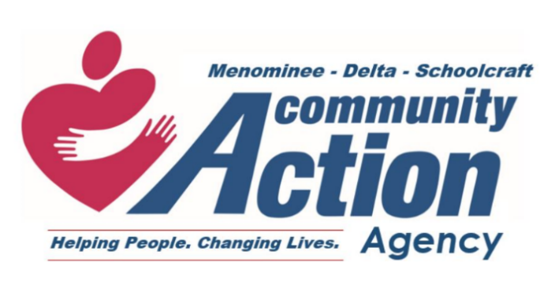
507 1st Ave. N
Escanaba, MI 49829
(906) 786-7080 – Phone
(906) 789-9423 – Fax
The Menominee-Delta-Schoolcraft Community Action Agency is currently accepting applications for the following position:

Job Title: Floating Center Aide
Position Type: Part-time, hourly, non-exempt
Hours: 32 hours/40 weeks
Location: Delta County

Pay Range: $13.39-$17.23 depending on education and experience.

Benefits: Benefits include paid time off; 403(b) retirement plan; and access to our Employee Assistance Program.

Job Summary: The floating center aide works as an effective team member with all classroom teams in providing quality child development, health, disabilities, and transportation services that meet or exceed all regulatory requirements as directed.

Qualifications: High school diploma/GED required. Some early childhood training/coursework is preferred.

How to Apply: A full job description can be found on our website (www.mdscaa.org/job-board).

Applications can be completed using the following link: https://pdf.ac/2X1yo9

A paper application can also be picked up at any of our centers and sent to MDSCAA, Attention: Human Resources, 111 N 5th St, Escanaba, MI 49829 OR emailed to hr@mdsecp.org.

Posting will remain open until December 12th, 2025

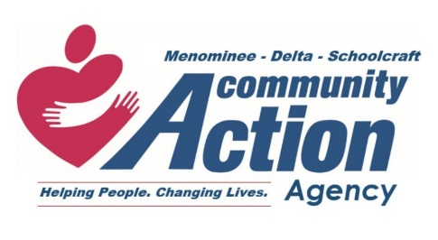

Job Title: | Center Aide/Bus Monitor/Floating Center Aide |  | Revised: | 10/2024
Program: | Early Childhood |  | Reports To: | Assigned Teacher
Location: | As assigned
Classification: | Non-exempt, hourly |  | Supervises: | None

POSITION OVERVIEW
The Center Aide supports the classroom through tending to both the needs of the teacher and the children.

EDUCATION & EXPERIENCE
- High school diploma/GED required. Some early childhood training/coursework is preferred.
- Experience with preschool children is preferred.

REQUIRED SKILLS/ABILITIES
- Ability to engage with children utilizing proper communication and physical actions.
- Excellent written and verbal communication skills.
- Adhere to strict client confidentiality.
- Submit to criminal background check.

DUTIES/RESPONSIBILITES
- Work as an effective team member in providing quality child development/health, disabilities and transportation services that meet or exceed all regulatory requirements as directed.
- Constant and active supervision is maintained when staff member is working with children, in any capacity.
- The health and safety of children in the care of the program is a priority for staff in any capacity.
- Assist with family involvement activities as assigned, to include but not limited to: providing child care, food service, activity prep and clean-up.
- Perform daily general and periodic cleaning, as assigned.
- Perform tasks related to food service to include but not limited to: monitor inventory and notify the Center Administrator or kitchen aide of the food service supplies needed, address food service concerns, coordinate menu posting, changes and substitutions, as assigned and directed by supervisor.
- Develop and implement ongoing professional development goals as approved and/or assigned.
- Actively support program efforts to initiate and maintain community partnerships to promote communication, cooperation and sharing of information among local, state or national committees/advisory groups/boards to improve services to children and families.
- Participate in recruitment efforts as assigned or needed.
- Develop and maintain competency in the use of a variety of technology systems as directed by supervisor.
- Complete all documentation and reporting requirements in an accurate and timely manner.
- Support the program’s efforts to generate Non-Federal Share.
- Maintain regular and punctual work attendance.
- Abide by all CAA/Early Childhood Program Personnel Policies.
- Identify as a mandated reporter and follow all mandatory child abuse/neglect reporting procedures set forth by the program.

WORKING CONDITIONS & PHYSICAL REQUIREMENTS
- Prolonged periods of standing, walking, bending, kneeling, pushing and pulling.
- Must be able to lift up to 50 pounds occasionally.
- Possible exposure to inclement weather conditions and hazardous driving conditions.

This job description is not designed to cover or contain a comprehensive listing of job duties or responsibilities. Duties may be changed at any time with or without notice.

